- ----- is a measure for how correct the data and system are.
- correctness | - maintainability
- Integrity | - Security
- ………… is a measure for how well the system is protected against attacks only when they occur.
- correctness | - maintainability
- Integrity | - Security

- Which SQFs are not independent?
- Integrity & maintainability | - Integrity & reliability
- Integrity & efficiency | - None of the above

- …. is used for measuring correctness:
- KLOC | - MTTC
- Probability of attack | - None of the above

- To ensure integrity, email validate occurs at …………..
- Server side | - Client side
- Both client and server side | - User side
- To ensure integrity, email verification involves sending a random code to the target email address. This occurs at …………..
- Server side | - Client side
- Both client and server side | - User side

- ………. where data is chosen to cause an application to function incorrectly
- Input attacks | - Denial of service
- Accidental attacks | - Man in the middle and replay

- Which of the following is software quality factors that measures the security ….. :
- Portability | - Denial of service
- Integrity | - Reliability

A web server has been running for a month. From the log ﬁles for that month we see that, of 4000 accesses, 300 attacks were made. Of these, 150 were denial-of-service attacks, of which 42 were successful, 90 were password guessing (of which 35 were successful) and 60 were accidental attacks (caused by errors on the part of the user), of which 20 were successful.

- The threat probability of denial-of-service or password guessing …..:

- The security probability of accidental attack ….:

- he security probability of denial-of-service or accidental attacks …..:

- Which code of the following is more complex?
Code A:
int number=100;
System.out.print("List of even numbers from 1 to "+number+": ");
for (int i=1; i<=number; i++)
{
if (i%2==0)
{
System.out.print(i + " ");
}
}

Code B:
int number=20;
switch(number){
case 10:
System.out.println("10");
break;
case 20:
System.out.println("20");
break;
case 30:
System.out.println("30");
break;
default:
System.out.println("Not in 10, 20 or 30");
}
Code C:
int number = 987654, reverse = 0;
while(number != 0)
{
int remainder = number % 10;
reverse = reverse * 10 + remainder;
number = number/10;
}
System.out.println("The reverse of the given number is: " + reverse);

Code D:
boolean b1=true;
boolean b2=false;
String s1=String.valueOf(b1);
String s2=String.valueOf(b2);
System.out.println(s1);
System.out.println(s2);
- A | - B
- C | - D

- Given the following code
from flask import Flask, request
from flask_restful import Resource, Api
from sqlalchemy import create_engine
from json import dumps
from flask.ext.jsonpify import jsonify
db_connect = create_engine('sqlite:///chinook.db')
app = Flask(__name__)
api = Api(app)
class Employees_Name(Resource):
def get(self, employee_id):
conn = db_connect.connect()
query = conn.execute("select * from employees where EmployeeId =%d " %int(employee_id))
result = {'data': [dict(zip(tuple (query.keys()) ,i)) for i in query.cursor]}
return jsonify(result)
The above code is an example for a web route that can be called by [http://127.0.0.1:5002/employees/8 ] It is vulnerable to security the following attacks.

- URL guessing | - Password guessing
- SQL Injection | - Both A and C

- What is Employees in the following line: api.add_resource(Employees, '/employees'):
- Class | - Function name
- Database name | - Database table name
- A user types ”http://127.0.0.1:5002/employees/..... which of the values is a sql injection if typed instead of the dots?
- 20196000 | - *
- 1=1 | - ‘20196000’ or 1=1

24@app.post("/url", response_model=schemas.URLInfo)
25def create_url(url: schemas.URLBase, db: Session = Depends(get_db)):
26 if not validators.url(url.target_url):
27 raise_bad_request(message="Your provided URL is not valid")
28
29 chars = "ABCDEFGHIJKLMNOPQRSTUVWXYZ"
30 key = "".join(secrets.choice(chars) for _ in range(5))
31 secret_key = "".join(secrets.choice(chars) for _ in range(8))
32 db_url = models.URL(
33 target_url=url.target_url, key=key, secret_key=secret_key
34 )
35 db.add(db_url)
36 db.commit()
37 db.refresh(db_url)
38 db_url.url = key
39 db_url.admin_url = secret_key

- What is the purpose of line 26 and 27 ?
- Validate the URL | - provide random strings for key and secret_key.
- Create a database connection. | - match the required URLInfo schema that you need to return at the end of the function.

- What is the purpose of line 32 to 37?
- Validate the database URL | - provide random strings for key and secret_key.
- create a database connection. | - match the required URLInfo schema that you need to return at the end of the function.

- A function decorator that tell Flask virtual webhost what URL should trigger our function is -----------
- Route() | - Run()
- Api() | - Start()

- Which metric is used to measure the level of coupling between objects?
- NOC metric | - ) DIT metric
- CBO metric | - None of the above

- Use the following class diagram to compute depth of inheritance tree (DIT).
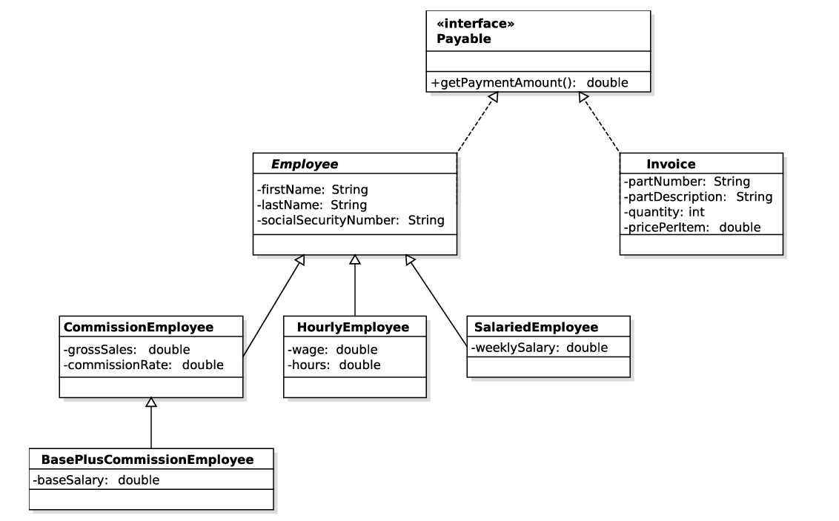

A) DIT=1 for class Employee | B) DIT=2 for class BasePlusComissionEmployee
C) DIT=1 for class BasePlusComissionEmployee | D) DIT=2 for class HourlyEmployee

- What's the complexity of the following code using LOC metric and McCabe's Cyclomatic complexity metrics
- int i = 1;
- int j = 0;
- while (i <= 5 ) {
- playACard(i);
- if (playerHasWon(i) && j < 2) {
- break;
- } else if (playerHasLost(i)) {
- System.out.println("Player " + i + " has lost the game!");
- }
- if (i % 2 == 0) {
- System.out.println("Player " + i + " has an even card.");
- } else {
- System.out.println("Player " + i + " has an odd card.");
- }
- j++;
- i++;
- }
A)LOC=17 , complexity =6 | B) LOC=17 , complexity =5
C) LOC=14 , complexity =5 | D) LOC=14 , complexity =6
- Which of the following lines connect to Database
- db_connect = create_engine('sqlite:///chinook.db') | - query = conn.execute()
- conn=db_connect.connect() | - db = SessionLocal()

- ….. attack is the exploitation of the web-session & its mechanism that is usually managed with a session token.:
- Session Hacking | - Session Hijacking
- Session Cracking | - Session Compromising

- Cross-site scripting (XSS) …...:
- Injection of commands | - Injection of parameters
- Injection of scripts | - All of the above

- ….. is a type of attack that tricks site users or administrators to unknowingly perform malicious actions for the attacker like changing order values and product prices, transfer funds from one account to another, change user passwords to hijack accounts.:
- SQL Injection | - Command Injection
- Cross-Site Scripting (XSS) | - Cross-Site Request Forgery (CSRF)
- When people send you phony emails, pop-up messages, social media messages, texts, calls, or links to fake websites in order to hook you into giving out your personal and financial information:
- Pharming | - Identity Theft
- Phishing | - Password attack
- Which of the following is NOT a characteristic of a web session?
- Created when a user logs in to a web application | - Stored on the client-side
- Can store user-specific data | - Created when a user visits a website for the first time

- What is the primary purpose of a session ID?
- To identify the user who is logged in to a web application | - To store user-specific data on the client-side
- To establish a secure connection between the client and server | - To prevent unauthorized access to a web application

- Which statement defines session hijacking most accurately?
- Session hijacking involves stealing a user’s login information and using that information to pose as the user later.
- Session hijacking involves assuming the role of a user through the compromise of physical tokens such as common access cards.
- Session hijacking is an attack that aims at stealing a legitimate session and posing as that user while communicating with the web resource or host machine.
- Session hijacking involves only web applications and is specific to stealing session IDs from compromised cookies.

- What type of vulnerability occurs by clicking on a link not from a legit source where imitate the original website?
- SQL injection | - phishing
- cross site scripting | - monitoring
- What is the relation between Vulnerability , Threat & Risk ?
- Vulnerability = Risk X Threat | - Risk = Vulnerability X Threat
- Threat = Risk X Vulnerability | - No relation exist

- Which phase in the kill chain considers the most critical & important one ?
- Exploitation | - Weaponization
- Reconnaissance | - Delivery

- What is the best practice format for storing user passwords in the database?
- Stored in a Hashed format | - Stored encrypted
- Stored Clear Text | - None of above

- Which of the following consider main security controls that should be followed during the application development cycle ?
- Follow the two-tier design best practice | - Use SSLv3.0 for transmission encryption
- RUN SAST & DAST assessments | - All the above

- Which type of vulnerability considers logical vulnerability that could lead to a logical attacks scenario and can’t be detected during SAST assessment ?
- IDOR “Indirect Object Refrence” | - XSS “Cross Site Scripting”
- Weak Password Policy | - Lake of CSRF Tokens

- Sql Injection considers a vulnerability that occurs due to …
- Using insecure database engine | - Using java script to print user inputs
- Using Insecure database queries from application | - A&C

- Which of the following prevent unauthorized disclosure of information ?
- Integrity | - Availability
- Authorization | - Confidentiality

- In cybersecurity concepts, Triple A (AAA) stands for .. (Choose three)
- Authentication | - Accountability
- Authorization | - Administration

- Which aspect of the CIA Triad does Data signing support?
- Confidentiality | - Integrity
- Availability | - Accountability

- Which of the following are phases of the Cyber kill chain (Choose two)
- Initial Access | - Exploitation
- Execution | - Command and Control
- Persistence

- Which command is an example of a parameterized query (not vulnerable to SQL injection)?
- [C#] SqlCommand cmd = new SqlCommand("SELECT * FROM people WHERE LastName =" +LastName.Text+"')", conn);
- [PHP] $query = "SELECT * FROM people WHERE LastName =".$_POST['LastName'];
- [Python] cmd = "SELECT * FROM people WHERE LastName ='%s'" % (LastName)
- [JDBC] PreparedStatement statement = connection.prepareStatement( "SELECT * FROM people WHERE LastName = ?" ); statement.setString(1, LastName);

- Referring to the AAA Framework which is used to control access to computer resources, which of the following occurs first?
- Authentication | - Accountability
- Authorization | - Administration

- Which of the following considers mitigation for XSS & SQL injection ?
- Database Patching | - User Input Validation
- Use Encryption algorithm | - Use Anti-CSRF Token

- Which of the following are best practices for implementing strong authorization mechanism ? (Choose only Two)
- Use Prepared Statement | - Restrict user access to need to know
- Protect against CSRF | - Use HTTPs protocol

- Which of the following illustrate defense in depth methodology ?
- Physical Security | - Network Security
- Authorization | - A&B
- B&C

